Exercise1:
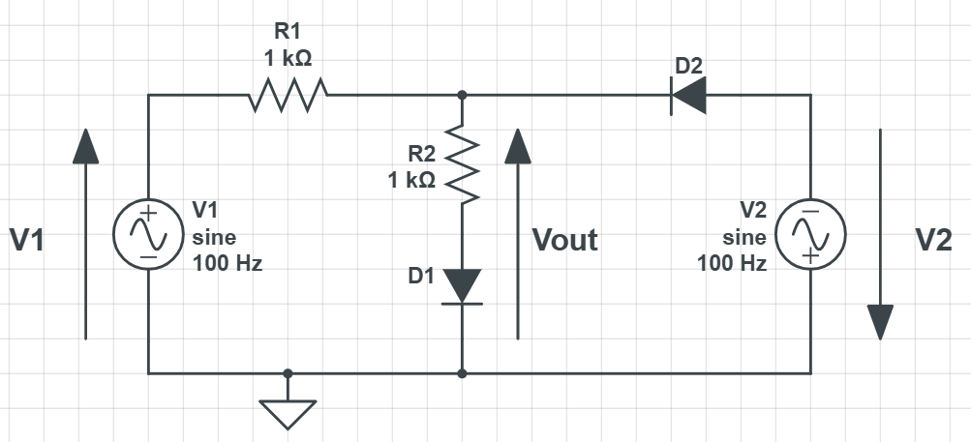
Given the circuit below. The first voltage source $V1$ is a sine wave with an amplitude of $2V$ and a frequency $f=100 Hz$. The second voltage source $V2$ is a sine wave with an amplitude of 1$V$ and a frequency $f=100 Hz$.
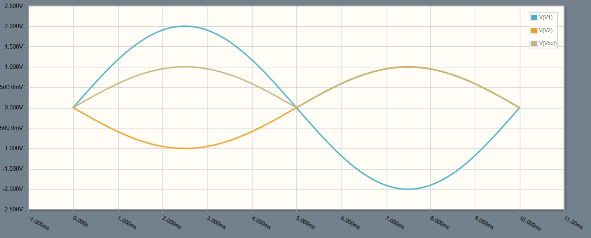
- Draw the output voltage $V_{out}$ for the first period, and precise the time and voltage values. $D1$ and $D2$ are ideal diodes. (1 point)

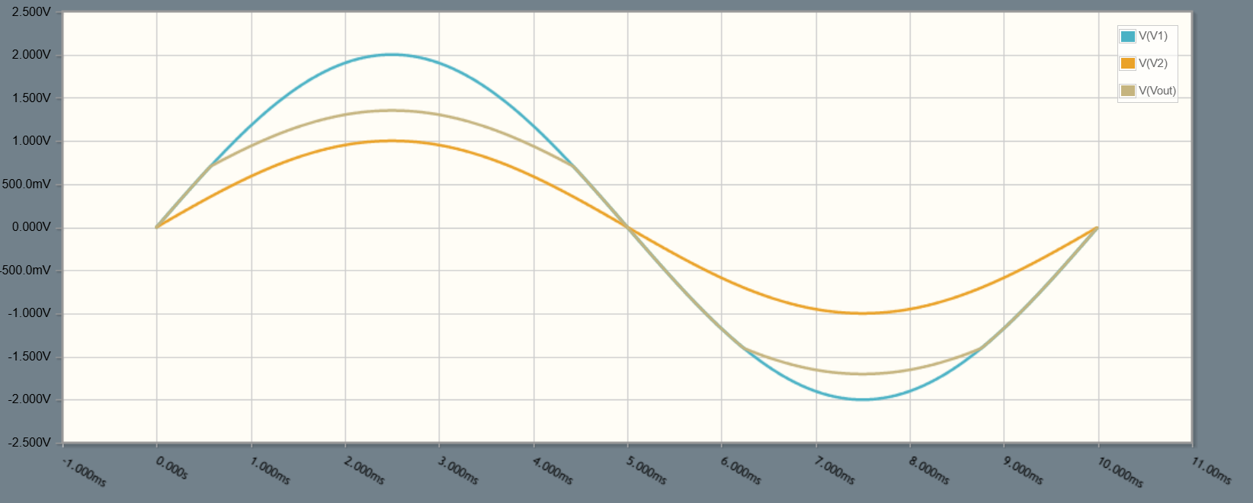
- Draw the output voltage $V_{out}$ if the second voltage source $V2$ has a phase of 180 degrees. $D1$ and $D2$ are real diodes with a voltage drop of $0.7V$ . (1 point)

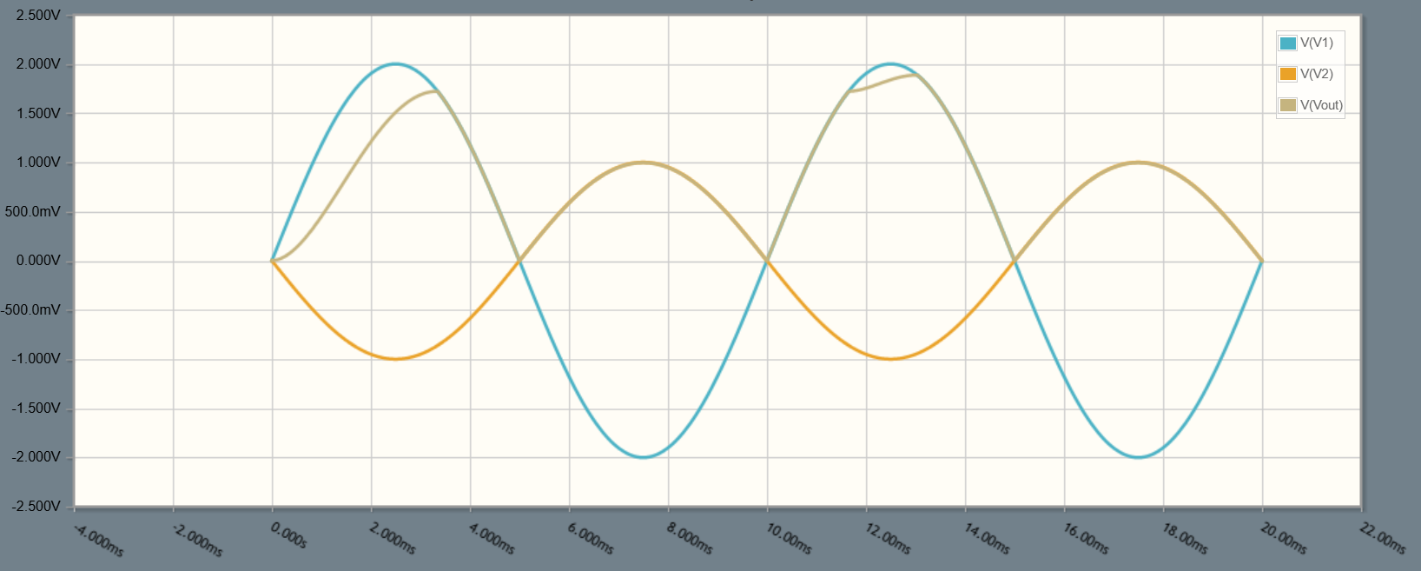
- Replace the resistor $R2$ with a capacitor $C=1 μF$. Draw approximately the output voltage $V_{out}$ for the first period. (Consider the original $V2$ without the phase. $D1$ and $D2$ are ideal diodes.) (2 points)

- Explain why is the output voltage $V_{out}$ in the second period the same as or different than the first period. (0.5 point)
The output voltage in the second period is different because the capacitor does not discharge.

